MIP First Grade Supply List 2020-2021

Listed below are supplies we suggest students bring to class this coming school year. This suggested list has been compiled based on needs identified to support the delivery of the grade level curriculum. Therefore, while this list suggests that students bring a number of items, it is considered voluntary. No student will be restricted from participation if the items are not sent to school.

Suggested List of School Supplies
*Note that with the exception of pencils, brand names are only a suggestion.

Child Specific Supplies

# | Item | # | Item
1 | Pencil Box (8.2” x 5.8” x 2”) | 12 | Dixon Ticonderoga Pencil
1 | Crayola Washable Markers – Broad Tip Classic Colors 8ct ONLY | 2 | 2-Pocket Plastic Folders WITHOUT prongs/brads
2 | Small Pencil Sharpener with Shaving Holder | 1 | 1” 3 Ring Binder Clear View/Cover
1 | Fiskars Scissors Pointed 5” | 1 | Small Whiteboard Eraser
3 | Large Eraser | 2 | Crayons 16ct ONLY
2 | Highlighter (Yellow) | 12 | Elmer’s Glue Stick
8 | Expo Dry Erase Markers (Black) | 1 | Backpack: large enough to hold a 10x13” folder and your child’s lunch container (NO ROLLER BACKPACKS
2 | Wired spiral notebook, one subject (70-80 pages)

Optional Classroom Donations (always appreciated)
- Disinfecting Wipes
- Facial tissues
- Letter Sheet Protectors
- Ziploc bags (gallon & sandwich size)
- Treasure Box Prizes
- Colored construction paper
- Small white board erasers

First day of school

For the first day of school, the following items should be placed in your child’s pencil box:
- (1) Elmer’s Glue Stick
- (1) Highlighter (Yellow)
- (1) Crayons 16ct only
- (1) Large Eraser
- (1) Expo Dry Erase Marker (Black)
- (1) Fiskars Scissors Pointed 5”
- (1) Small Pencil Sharpener w/Shaving Holder
- (1) Crayola Washable Markers – Broad Tip Classic Colors 8ct only
- (2) Sharpened Dixon Ticonderoga pencil
- (1) Small Whiteboard Eraser

The remainder of the suggested school supplies listed on the first page should be placed in a bag and given to the teacher on the first day of school. These should NOT be labelled with your child’s name.

See the example below-Label the pencil box with your child’s name

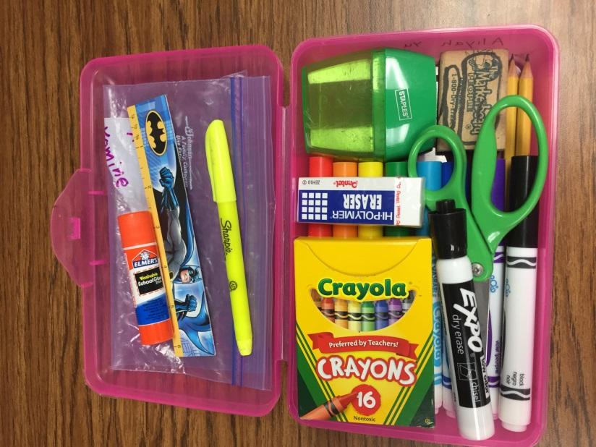

Please note that the Constitution of the State of California requires that we provide a public education to you free of charge. Your right to a free education is for all school/educational activities, whether curricular or extracurricular, and whether you get a grade for the activity or class. Subject to certain exceptions, your right to a free public education means that we cannot require you or your family to purchase materials, supplies, equipment or uniforms for any school activity, nor can we require you or your family to pay security deposits for access, participation, materials, or equipment.

